ANUPRATHA.C
192573024
CO1_AT1_APPLICATION-BASED QUESTION

Q1). Application: Cloud Storage Processing System
Aim:
To determine the time complexity of the recurrence relation T(n) = 3T(n/2) + n using the Master Theorem, identify the applicable case, and analyze its efficiency for large cloud storage systems.
Algorithm:
- Identify the values of a, b, and f(n).
- Compute n^(log_b a).
- Compare f(n) with n^(log_b a).
- Identify the correct Master Theorem case.
- Derive the asymptotic time complexity.
- Analyze the performance for large cloud storage systems.
Source Code:
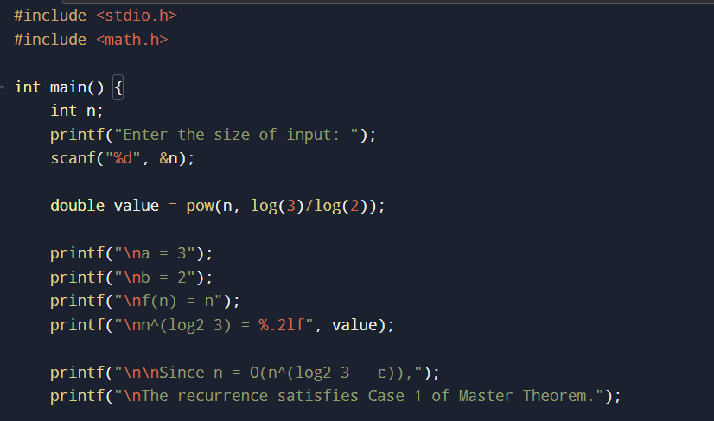
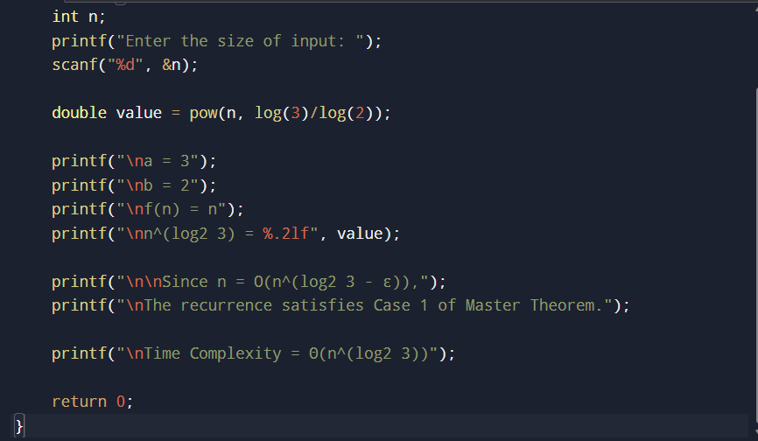

Step-by-step procedure:
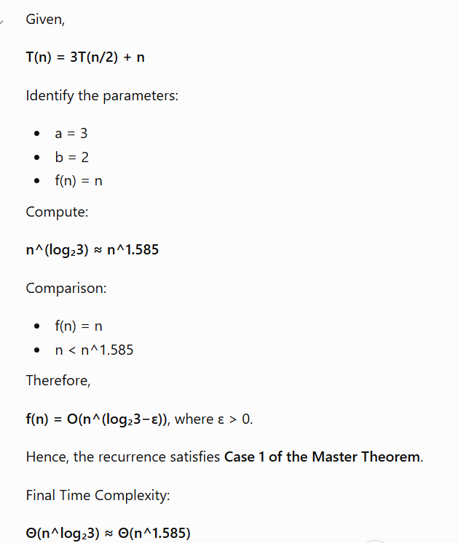

Sample Input and Output:

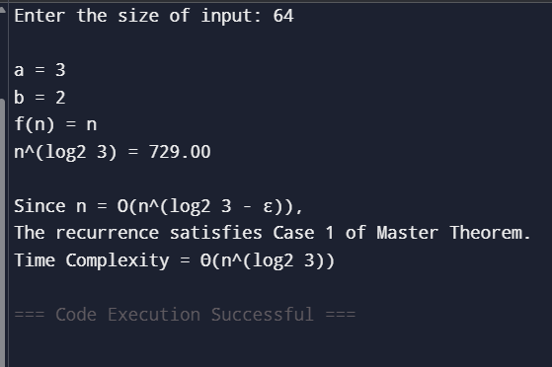

Result:
The recurrence T(n)=3T(n/2)+n satisfies Case 1 of the Master Theorem. The overall time complexity is Θ(n^log₂3) ≈ Θ(n^1.585), making it efficient for large-scale cloud storage systems.

Q2). Application: Real-Time Search Index Compression
Aim:
To solve the recurrence relation T(n)=T(n/2)+log n using the Substitution Method, derive the asymptotic time complexity, and analyze its efficiency in real-time search indexing.
Algorithm:
- Write the recurrence relation.
- Expand recursively using substitution.
- Continue until the base case.
- Express the recurrence as a summation.
- Evaluate the summation.
- Derive the asymptotic complexity.
- Analyze recursion depth and efficiency.
Source Code:
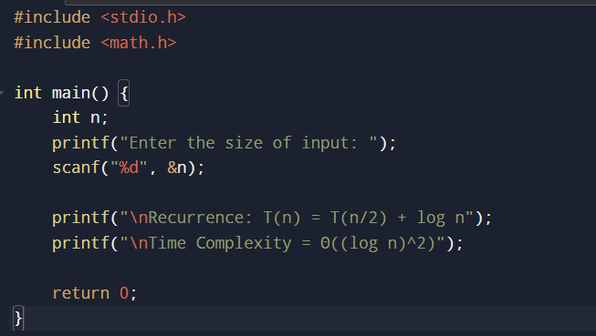
Step-by-step procedure:
Given,
T(n)=T(n/2)+log n
Expand:
T(n)
= T(n/2) + log n
= T(n/4) + log(n/2) + log n
= T(n/8) + log(n/4) + log(n/2) + log n

= T(1) + Σ log(n/2^i)
The recursion depth is:
log₂n
The sum of logarithms is:
Θ((log n)²)
Therefore,
T(n)=Θ((log n)²)

Sample Input and Output:

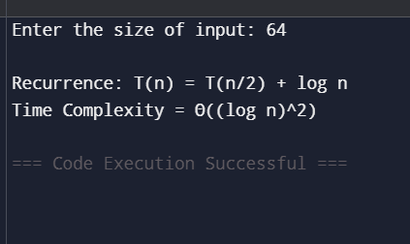

Result:
The recurrence T(n)=T(n/2)+log n is solved using the Substitution Method. The overall time complexity is Θ((log n)²). The algorithm performs efficiently for large search indexes due to its shallow recursion depth and logarithmic growth.

